Name: NGO TUNG CHUONG
ID: s225586848

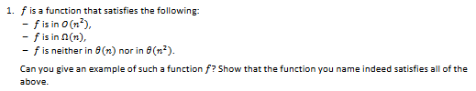
$$n<f\left(n\right)<n^{2}$$
$$f\left(n\right)=n*\log\left(n\right)$$

Condition 1 | Condition 2 | Condition 3 | Condition 4
$$f is in O(n^{2})$$ | $$f is in ω(n)$$ | $$f is not in ⊝(n)$$ | $$f is not in ⊝(n^{2})$$
$$n\log\left(n\right)≤c*n^{2}, ∀n≥n_{o}$$ | $$nlog\left(n\right)≥c*n, ∀n≥n_{0}$$ | $$\lim_{n→∞}{\frac{nlog\left(n\right)}{n}=\lim_{n→∞}{\log\left(n\right)=∞}}$$ | $$\lim_{n→∞}{\frac{nlogn}{n^{2}}=\lim_{n→∞}{\frac{logn}{n}}}$$
$$Since\log\left(n\right)<n,∀n>0$$ | $$\log\left(n\right)≥c$$ |  | Using L’s Hôpital Rule:  $$\lim_{n→∞}{\frac{\frac{1}{n}}{1}}=0$$
$$nlog\left(n\right)<n*n$$ | For any $n≥2$ (Pick 2 due to base 2 for the log), $logn≥1$ | Because the limit is infinity, f(n) grows strictly faster than n | Because the limit is zero, f(n) grows strictly slower than $n^{2}$
This hold for $c=1, n_{0}=1.$ Thus $f(n)∈Ω(n^{2})$ | This holds for $c=1, n_{0}=2$. Thus, $f\left(n\right) ϵ Ω(n)$ | Therefore, $f(n)∉⊝(n)$ | Therefore, $f(n)∉⊝(n^{2})$

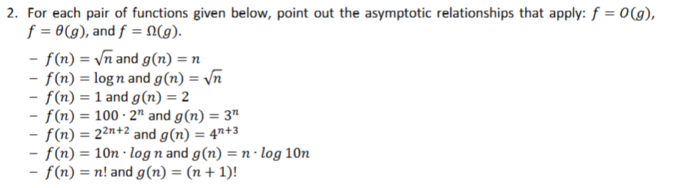
$$1. f\left(n\right)=\sqrt{n} and g\left(n\right)=n$$
$$\lim_{n→∞}{\frac{f\left(n\right)}{g\left(n\right)}}=\frac{\sqrt{n}}{n}=\frac{1}{\sqrt{n}}=\frac{1}{0}=0$$
$$f=O(g)$$
$$2. f\left(n\right)=\log\left(n\right)and g\left(n\right)=\sqrt{n} \\ \lim_{n→∞}{\frac{f\left(n\right)}{g\left(n\right)}}=\frac{\log\left(n\right)}{\sqrt{n}}.Using L^{'}s Hopital Rule$$
$$\lim_{n→∞}{\frac{\frac{1}{n}}{\frac{1}{2\sqrt{n}}}=\lim_{n→∞}{\frac{2\sqrt{n}}{n}=\lim_{n→∞}{\frac{2}{\sqrt{n}}=0}}} \\ f=O(g)$$
$$3. f\left(1\right)=1 and g\left(n\right)=2 \\ \lim_{n→∞}{\frac{f\left(n\right)}{g\left(n\right)}}=\frac{1}{2}=0.5 \\ f=⊝\left(g\right)$$
$$4. f\left(n\right)=100*2^{n} and g\left(n\right)=3^{n} \\ \lim_{n→∞}{\frac{f\left(n\right)}{g\left(n\right)}}=\frac{{100*2}^{n}}{3^{n}}=100*{\left(\frac{2}{3}\right)}^{n}. Since\frac{2}{3}<1 \\ 100*0=0 \\ f=O(g)$$
$$5. f\left(n\right)=2^{2n+2} and g\left(n\right)=4^{\left(n+3\right)} \\ f\left(n\right)=2^{2}*{\left(2^{2}\right)}^{n}=4*4^{n} \\ g\left(n\right)=4^{3}*4^{n}=64*4^{n} \\ \lim_{n→∞}{\frac{f\left(n\right)}{g\left(n\right)}}=\frac{4*4^{n}}{64*4^{n}}=\frac{4}{64}=\frac{1}{16} \\ f= ⊝(g)$$
$$6. f\left(n\right)=10nlog\left(n\right)and g\left(n\right)=nlog\left(10n\right) \\ g\left(n\right):\log\left(10n\right)=\log\left(10\right)+logn. So, g\left(n\right)=nlogn+nlog\left(10\right) \\ \lim_{n→∞}{\frac{f\left(n\right)}{g\left(n\right)}}=\frac{10nlogn}{nlogn+nlog10}=nlogn*\frac{10}{1+\frac{log10}{logn}}=10+\left(1+0\right)=10 \\ f=⊝\left(g\right)$$
$$7. f\left(n\right)=n!and g\left(n\right)=\left(n+1\right)! \\ \lim_{n→∞}{\frac{f\left(n\right)}{g\left(n\right)}}=\frac{n!}{\left(n+1\right)!}=\frac{n!}{\left(n+1\right)*n!}=\frac{1}{n+1} \\ \lim_{n→∞}{\frac{1}{n+1}=0} \\ f=O(g)$$

